CS7637: Project 3 (Summer 2015)

**Due: July 19th at 11:59PM UTC-12 (anywhere on earth)**

Click [here](https://t-square.gatech.edu/portal/tool/e27483bf-2963-4489-80af-9ddd2350f2fc?assignmentId=/assignment/a/gtc-5ac1-e2bd-5df3-9e91-f40708f08467/f01182fe-ed9b-4d3e-8b37-a700c3f89267&panel=Main&sakai_action=doView_assignment) to submit your agent code, and click [here](https://t-square.gatech.edu/portal/tool/e27483bf-2963-4489-80af-9ddd2350f2fc?assignmentId=/assignment/a/gtc-5ac1-e2bd-5df3-9e91-f40708f08467/c32ec925-ff11-4e31-8f3f-b3b18dee5944&panel=Main&sakai_action=doView_assignment) to submit your project reflection.

**Assignment: Solving 3x3 RPM using Visual Representations.**

Make sure to read the more general project description [here](https://docs.google.com/document/d/1GkXYf6xG-jGzxM_Z5pwE2GkhCUvq369t7lmOI9YUVnQ/edit?usp=sharing) for a high-level introduction and description of the class project.

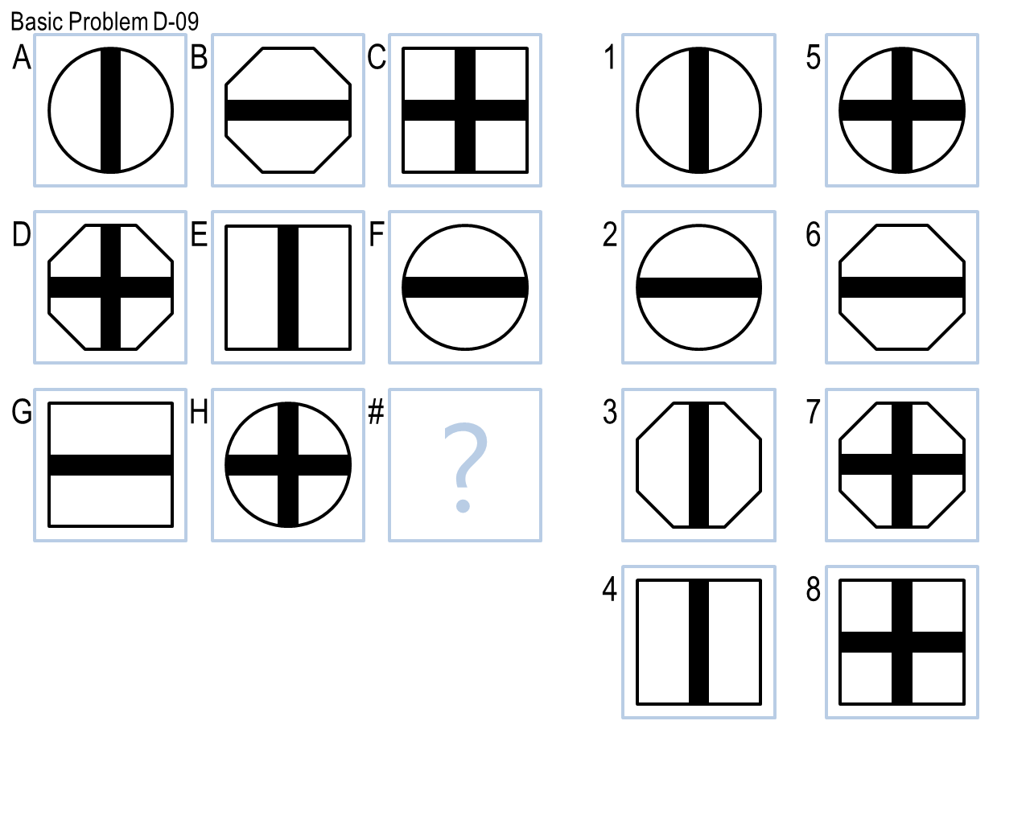

Project 3 is nearly identical to [Projects 1](https://docs.google.com/document/d/1ULlFP6bsnDKNJUNJDu7DdwOxAk1CM0m3R8HSYNh9FZ4/edit?usp=sharing) and [2](https://docs.google.com/document/d/1oA4r11n7NYNMaYOZlfUYC8u9_W37jzB5ZnGwJbusYHk/edit?usp=sharing). Thus, please consult the Project 1 and Project 2 directions for the majority of your information. Everything that applied to Projects 1 and 2also applies to Project 3.

The differences in Project 2 are:

* The due date is July 19th.
* Your agent will run against Problem Sets B, C, D, and E instead of just Problem Sets B and C.
* Problem Sets D and E are comprised of 3x3 problems that *only* have visual representations; there are no verbal representations in these sets.
* Your agent will be graded on its performance on [Basic](https://drive.google.com/file/d/0B-XdVjMuNV2GdjdJWmoxX0Y4Qmc/view?usp=sharing) Problem Sets D and E and Test Problem Sets D and E. It will not be graded on the other twelve sets it runs against.
* When submitting, you should use ‘Project3’ in the name of your .zip instead of ‘Project1’ or ‘Project2’.
* If your Project 3 agent outperforms your Project 1 or Project 2 agents on Basic or Test Problem Sets B or C, your Project 1 and/or Project 2 grade will be raised in accordance with the [Repeated Problem Set policy from the Overall Project Guidelines](https://docs.google.com/document/d/1GkXYf6xG-jGzxM_Z5pwE2GkhCUvq369t7lmOI9YUVnQ/edit?usp=sharing#heading=h.2u887ahws1xs).